## 

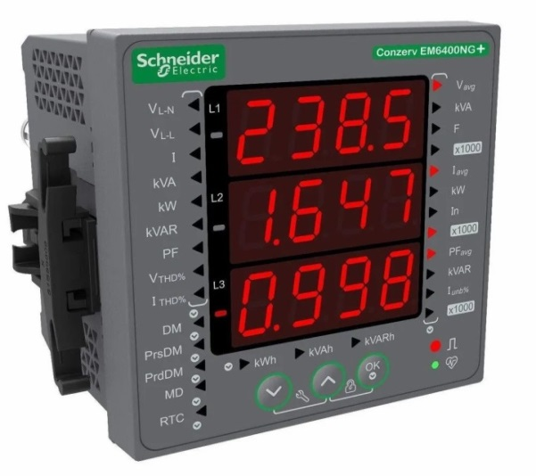

**PART REF: METSEEM6400NGPOCL1**

**DESCRIPTION-LOAD MANAGER: EM 6400 CL1.0 NG POP**



**PART REF-METSEEM6400NGPOCL5**

**DESCRIPTION-LOAD MANAGER: EM 6400 CL0.5S NG PO**



**PART REF-METSEEM6400NGRSCL1**

**DESCRIPTION-LOAD MANAGER: EM6400 CL1.0 RS485 NG**



**PART REF-METSEEM6400NGRSCL2**

**DESCRIPTION -LOAD MANAGER: EM6400 CL0.2 RS485 NG**



**PART REF- METSEEM6400NGRSCL5**

**DESCRIPTION -LOAD MANAGER:EM6400 CL0.5S RS485 NG**

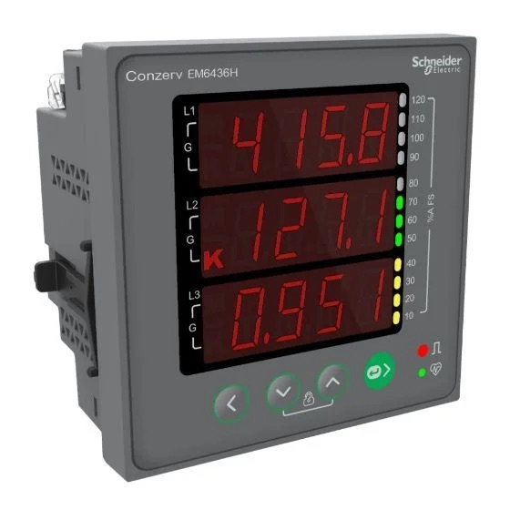

**PART NO-METSEEM6436HCL10RS**

**DESCRIPTION -EM6436H CL1.0 RS**



**PART NO-METSEEM6436HCL05RS**

**DESCRIPTION -EM6436H CL0.5 RS**



**PART NO-METSEEM6436HCL10**

**DESCRIPTION -EM6436H CL1.0NC**

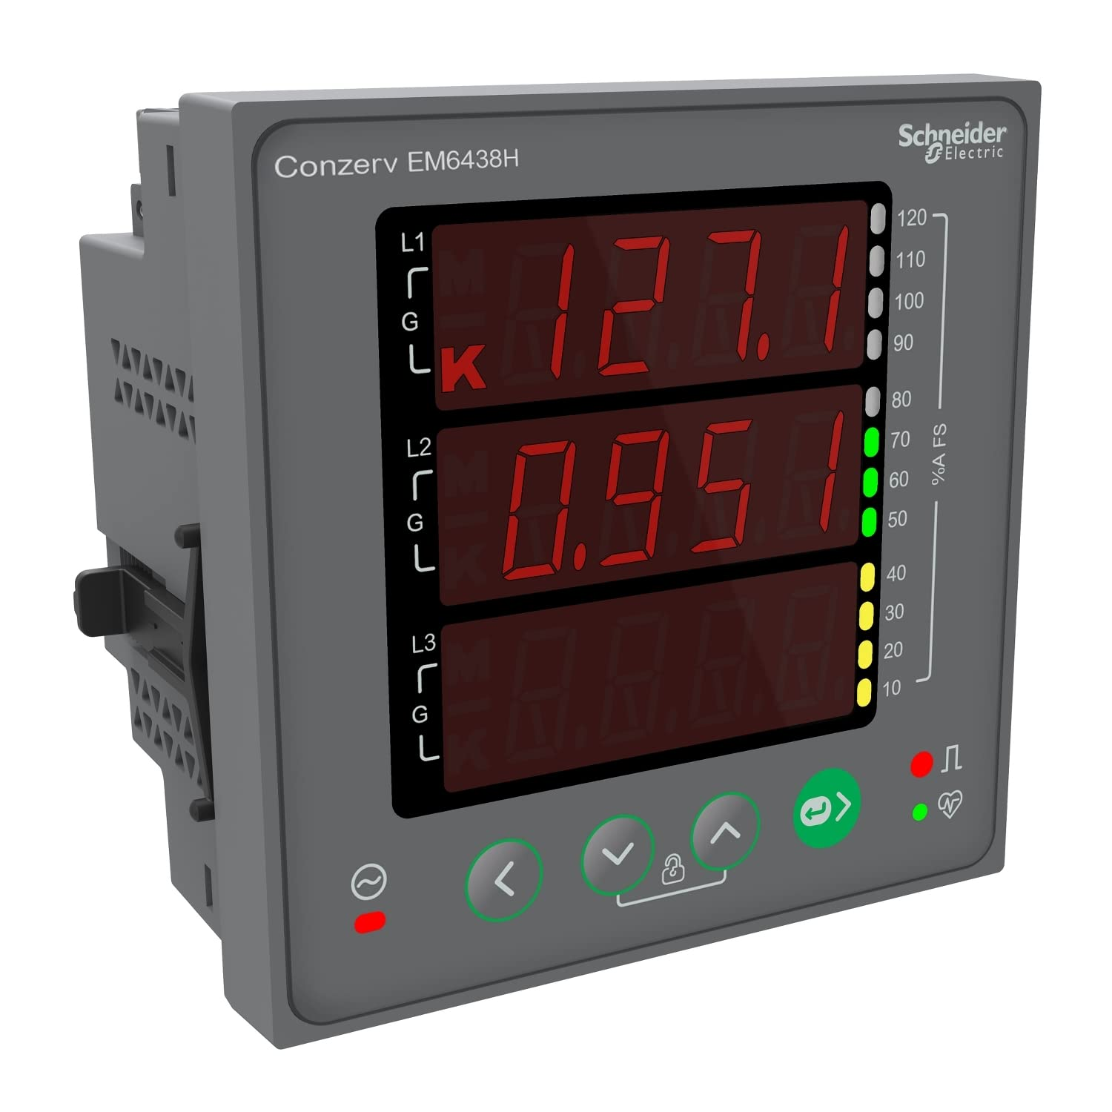

**PART NO-METSEEM6438HCL10RS**

**DESCRIPTION -EM6438H CL1.0 RS**

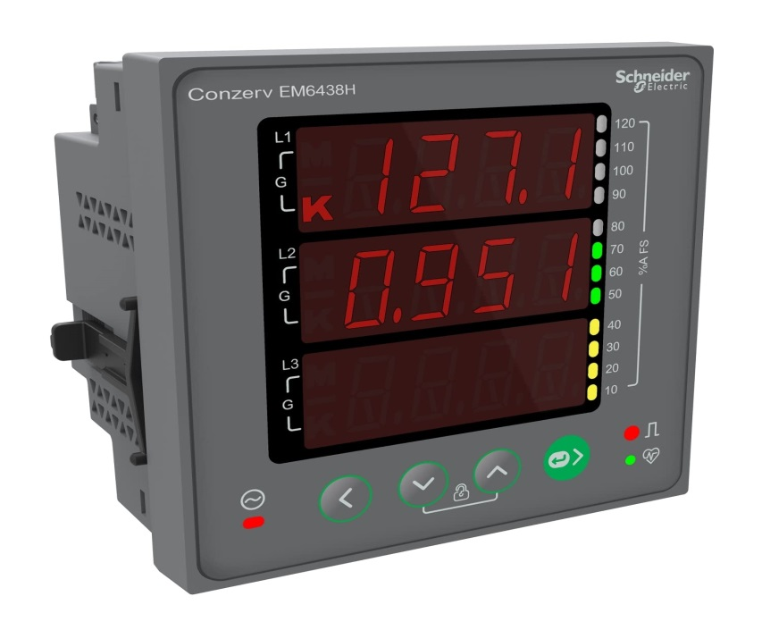

**PART NO-METSEEM6438HCL05RS**

**DESCRIPTION -EM6438H CL0.5 RS**

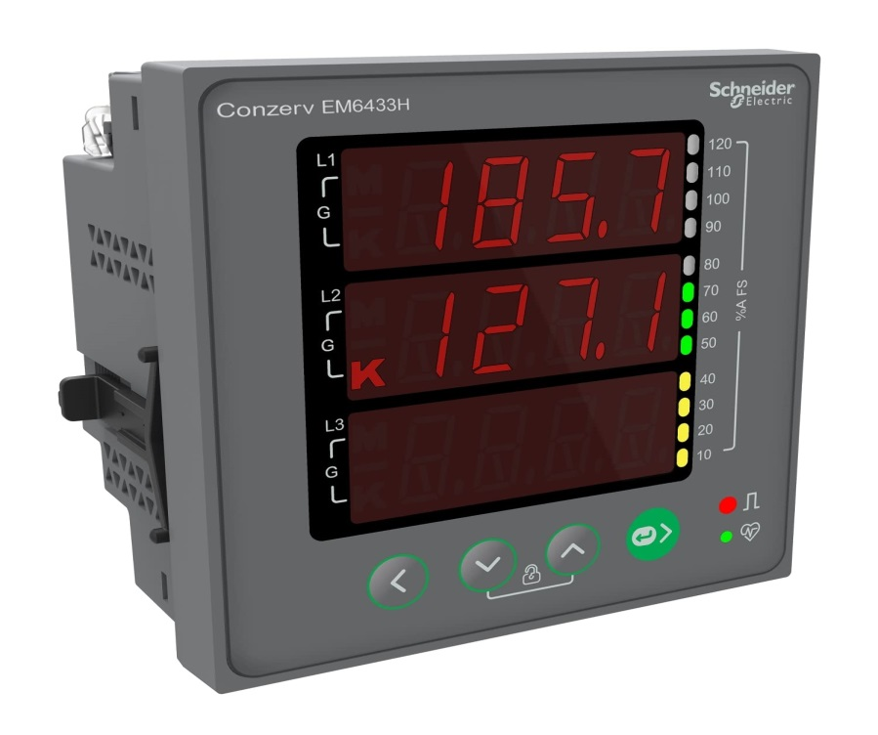

**PART NO-METSEEM6433HCL10RS**

**DESCRIPTION -EM6433H CL1.0RS**



**PART NO-METSEEM6433HCL05RS**

**DESCRIPTION -EM6433H CL0.5RS**

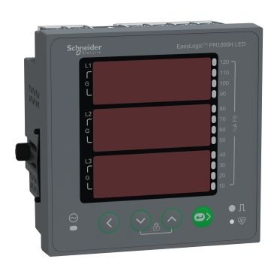

**PART NO- METSEPM1130HCL05RD**

**DESCRIPTION -PM1130H CL0.5 RS**

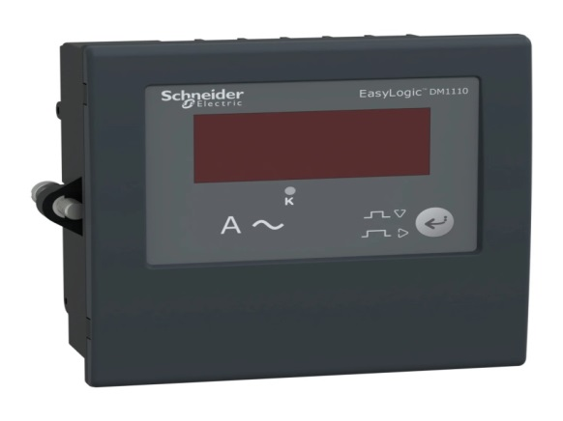

**PART REF-30002365**

**DESCRIPTION -AMMETER - DM1110 CL 1.0**



**PART REF-30002366**

**DESCRIPTION -AMMETER – DM1210 CL 1.0**

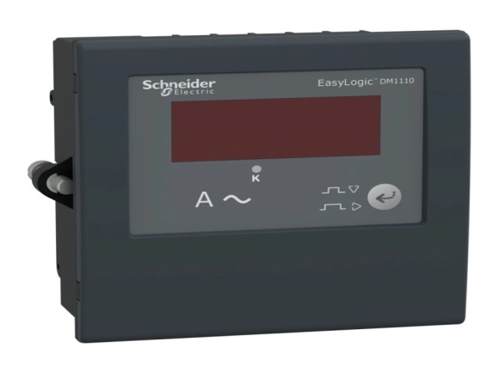

**PART REF-30002367**

**DESCRIPTION -FREQUENCY METER - DM 1310 CL 0.2**

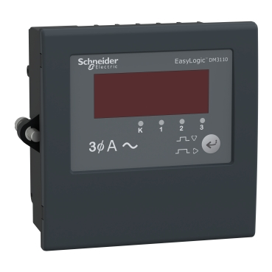

**PART NO-30002385**

**DESCRIPTION - AMMETER - DM3110 CL 1.0**

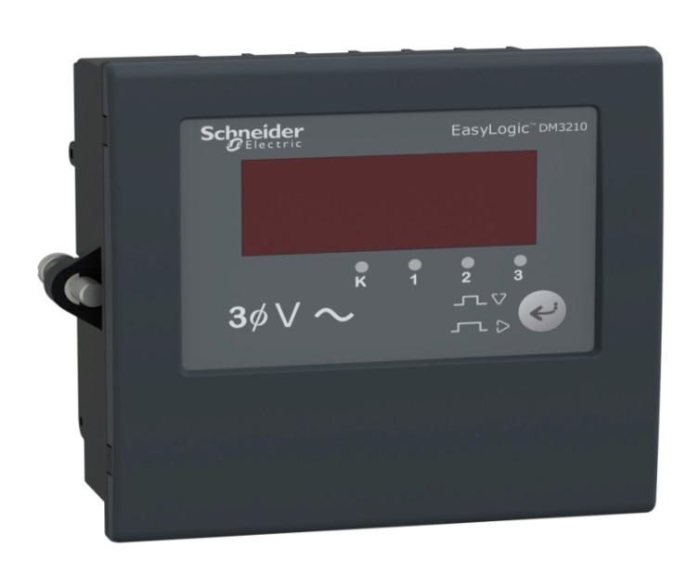

**PART NO-30002386**

**DESCRIPTION -VOLTMETER - DM3210 CL 1.0)**

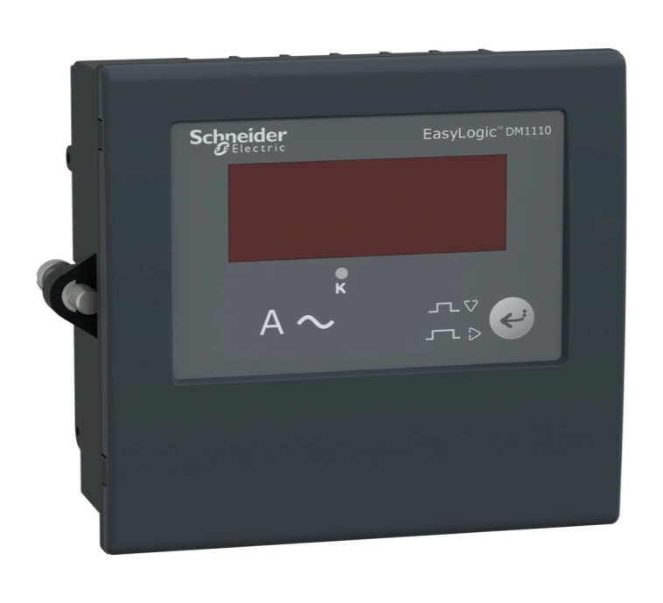

**PART NO-30002459**

**DESCRIPTION -AMMETER - DM1110 CL 0.5**

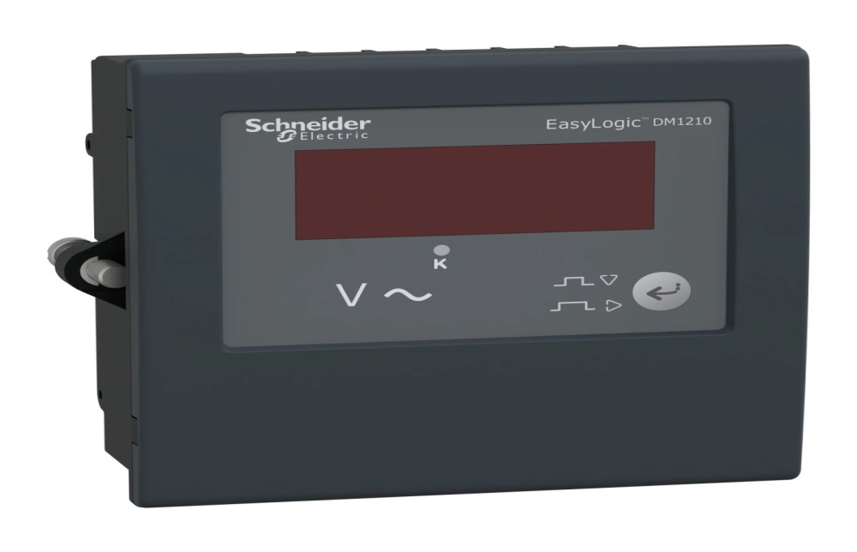

**PART NO- 30002460**

**DESCRIPTION-VOLTMETER - DM1210 CL 0.5**



**PART NO-30002461**

**DESCRIPTION-AMMETER - DM3110 CL 0.5**

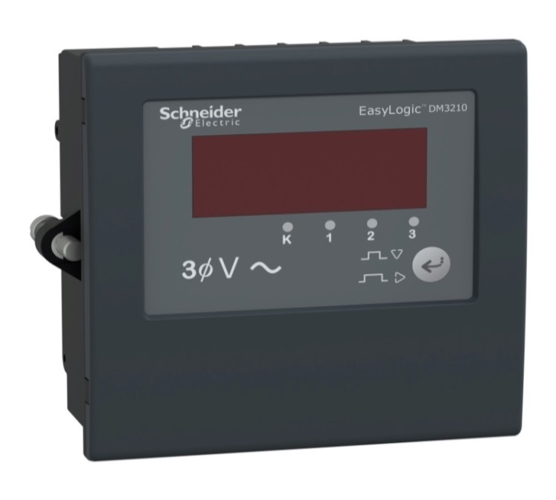

**PART NO-30002462**

**DESCRIPTION-VOLTMETER-DM3210 CL 0.5**

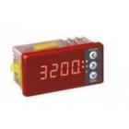

**PART REF-30000409**

**DESCRIPTION-ELF3234-3 CI1.0,**



**PART REF-30000859**

**DESCRIPTION-ELF3234 CI1.0,**

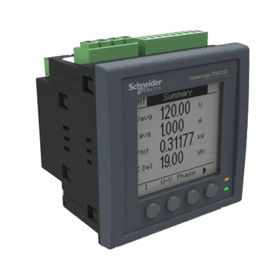

**PART NO-30002055**

**DESCRIPTION(DEMAND CONTROLLER:EM 7230 CL1.0 RS485)**



**PART NO-30002198**

**DESCRIPTION-DEMAND CONTROLLER:EM 7280 CL 0.5 RS485**

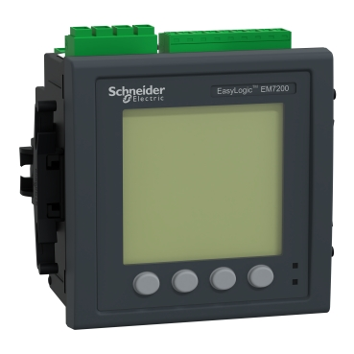

**PART NO-30002975**

**DESCRIPTION-DEMAND CONTROLLER:EM7290 CL 0.2 RS485**

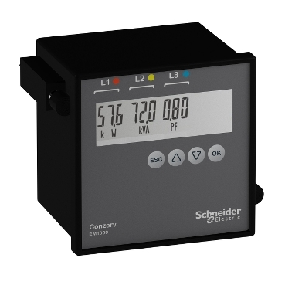

**PART NO-30002568**

**DISCRIPTION-ENERGY METER:EM1000 CL.1.0 WITH POP**

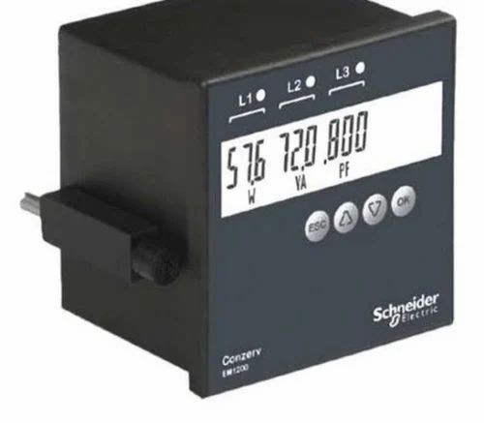

**PART NO-30002565**

**DESCRIPTION-ENERGY METER - EM1200 CL1.0 RS485**



**PART NO30002566**

**DESCRIPTION-VAF METER DM6300 CL1.0 WITH RS485**

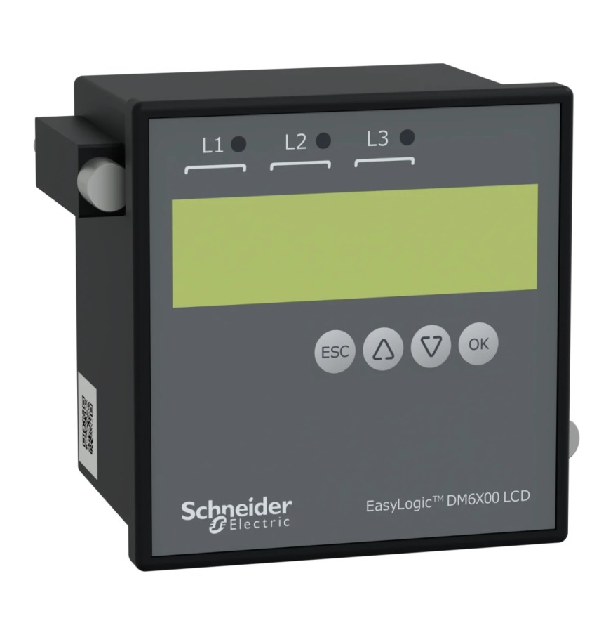

**PART NO-30002567**

**DESCRIPTION-VAF METER - DM6100 CL1.**



**PART NO-30002569**

**DESCRIPTION-VAF METER - DM6100 CL0.5**

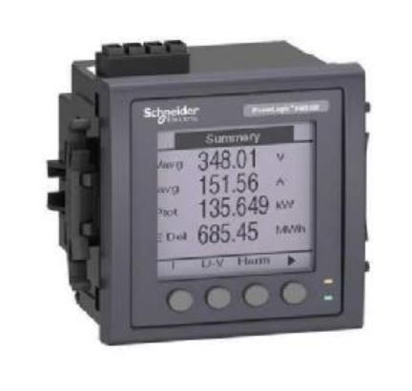

**PART NO-30003006D**

**DESCRIPTION-POWER METER:PM5330**

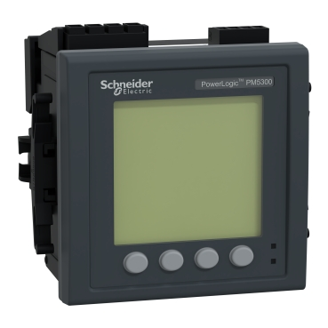

**PART NO- 30003006D**

**DESCRIPTION-POWER METER:PM5330**

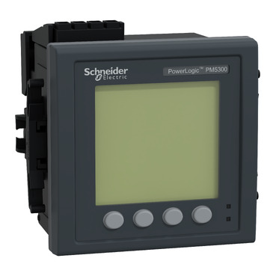

**PART NO-30003005D**

**DESCRIPTION-POWER METER:PM5320**



**PART NO-30003007D**

**DESCRIPTION-POWER METER :PM5340 CL.0.5S RS**

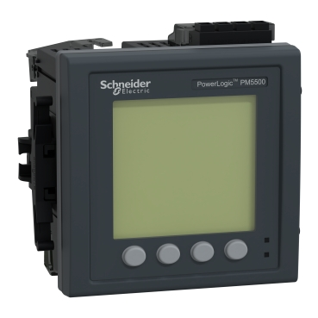

**PART NO-30003008D**

**DESCRIPTION-POWER METER:PM5560 CL0.02S RS485**

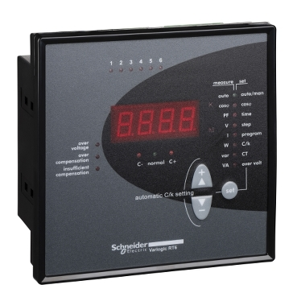

**PART NO-51207**

**DESCRIPTION- 6 STAGE RELAY:APFC**



**PART-51209**

**DESCRIPTION-8 STAGE RELAY:APFC**



**PART NO-51213**

**DESCRIPTION-12 STAGE RELAY:APFC**

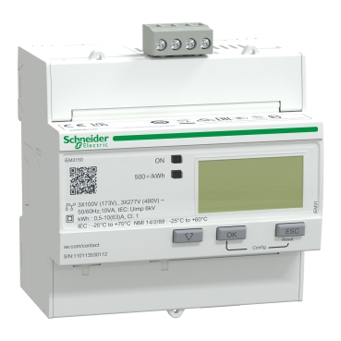

**PART NO-A9MEM3150**

**DESCRIPTION-ENERGY METER:A9MEM3150**

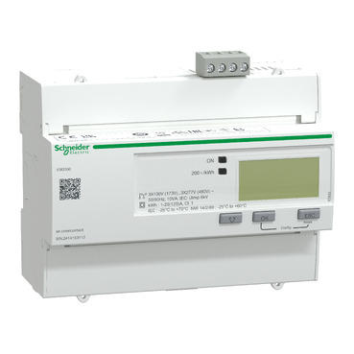

**PART NO-A9MEM3350**

**DESCRIPTION-TRIPHASE KWH METERS:A9MEM3350**

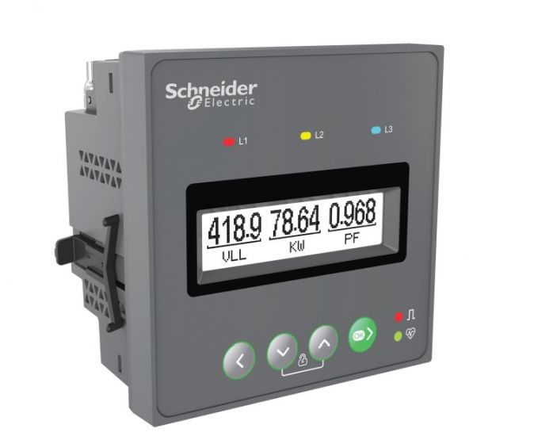

**PART NOMETSEEM1220HCL1**

**DESCRIPTION- EM1220H CL1.0 RS**

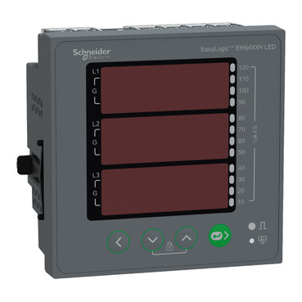

**PART NO-METSEEM6459HCL05RS**

**DESCRIPTION-EM6459H CL0.5 RS 485**



**PART NO-METSEEM6459HCL10NC**

**DESCRIPTION-VAF EM6459H CL1.0**



**PART NO-METSEEM6459HCL10RS**

**DESCRIPTION-EM 6459H CL 1.0 RS**

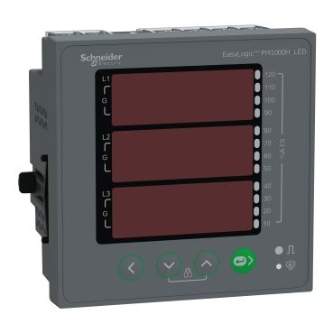

**PART NO-METSEPM1125HCL10RD**

**DESCRIPTION -EASY LOGIC PM1125H P&E THD RS485D CL 1.0**

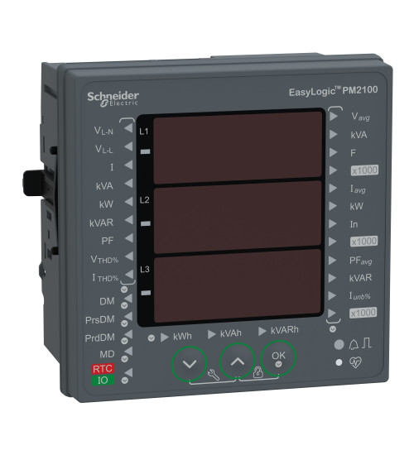

**PART NO-METSEPM2130D**

**DESCRIPTION - PM2130 CL0.5S RS485**

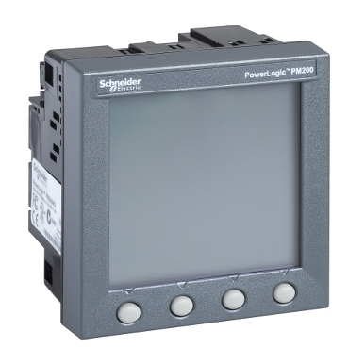

**PART NO-PM200MG**

**DESCRIPTION -POWER METER:PM200MG**

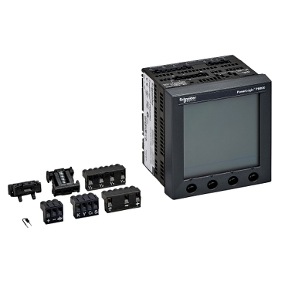

**PART NO-PM820MG**

**DESCRIPTION -POWER METER:PM 820 MG**

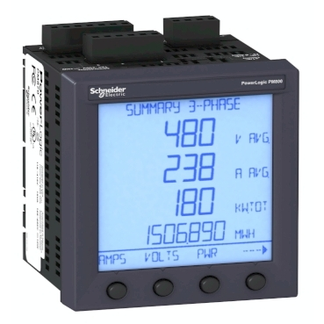

**PART NO-PM870MG**

**DESCRIPTION -POWER METER:PM870 MG**

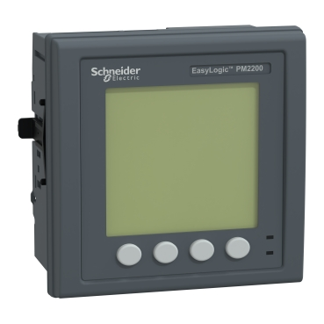

**PART NO-METSEPM2220D**

**DESCRIPTION -PM2220 POWER METER CL 1.0 RS485**



**PART NO-METSEPM2230D**

**DESCRIPTION -POWER AND ENERGY METER:PM2230 RS 485 CL .0.5S**

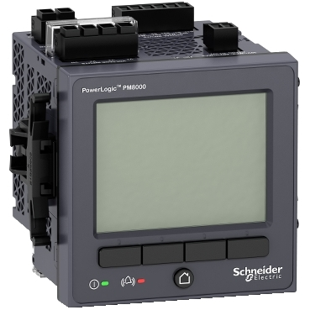

PART NO-METSEPM8240

**DESCRIPTION** -PM8240

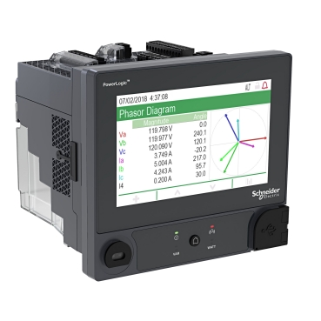

**PART NO-METSEION92040**

**DESCRIPTION-ION9000 STANDARD CVM STANDARD PSU W/ RMD**

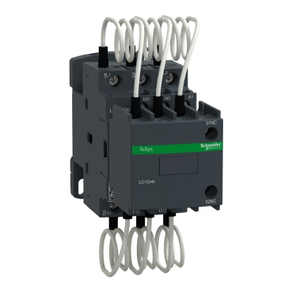

**PART NO-LC1DFKM7**

**DESCRIPTION -SCHNEIDER MAKE:CONTACTOR 12.5KVAR**

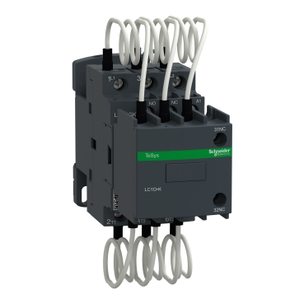

**PART NO-LC1DGKM7**

**DESCRIPTION -SCHNEIDER MAKE:CONTACTOR 16.7 KVAR**

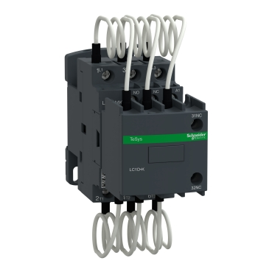

**PART NO-LC1DMKM7**

**DESCRIPTION -SCHNEIDER MAKE:CONTACTOR 25KVAR**

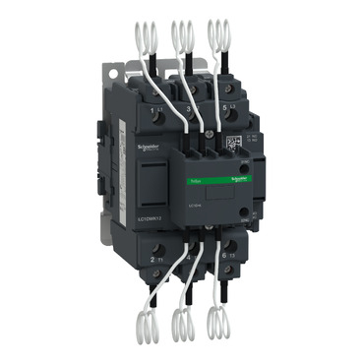

**PART NO-LC1DPKM7C**

**DESCRIPTION -SCHNEIDER MAKE:CONTACTOR 33.3**



**PART NO-LC1DTKM7C**

**DESCRIPTION -SCHNEIDER MAKE:CONTACTOR 40 KVAR**



**PART NO-LC1DWK12M7**

**DESCRIPTION -CONTACTOR CAPACITOR SWITCHING)**

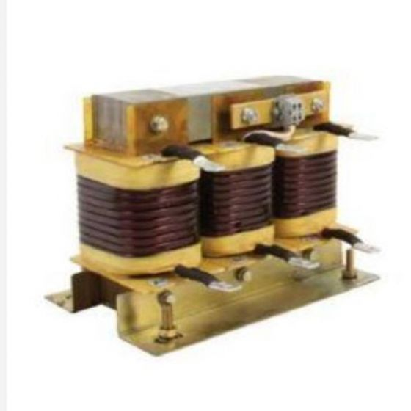

**PART NO-LVR07050A44LO**

**DESCRIPTION -REACTOR 5 KVAR 7%**



**PART NO-LVR07100A44LO**

**DESCRIPTION -REACTOR 10KVAR 7%**



**PART NO-LVR07150A44LO**

**DESCRIPTION -REACTOR 15 KVAR 7%**



**PART NO-LVR07250A44LO**

**DESCRIPTION -REACTOR 25KVAR 7%**



**PART NO-LVR07500A44LO**

**DESCRIPTION -REACTOR 50KVAR 7%**

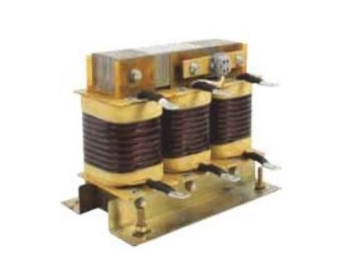

**PART NO-LVR07X00A44LO**

**DESCRIPTION -(REACTOR 100 KVAR 7%**

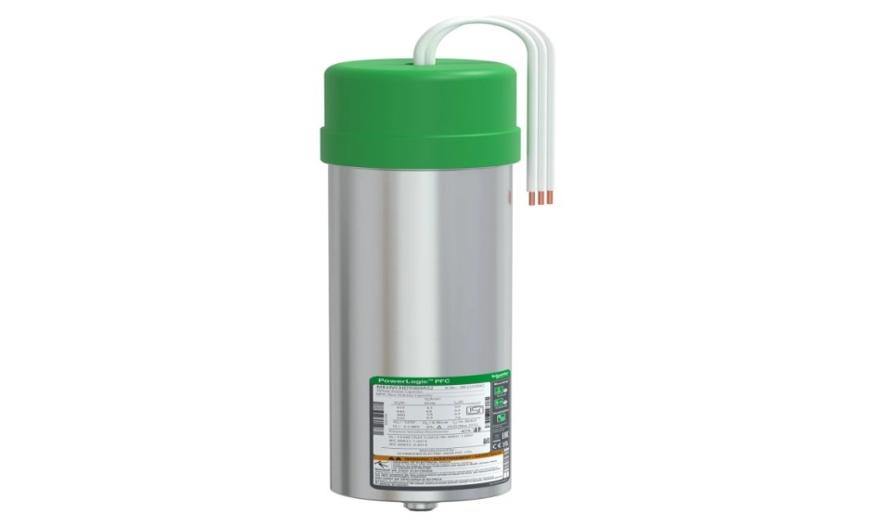

**PART NO-MEHVCHDY050A44**

**DESCRIPTION -5KVAR HD 440V**

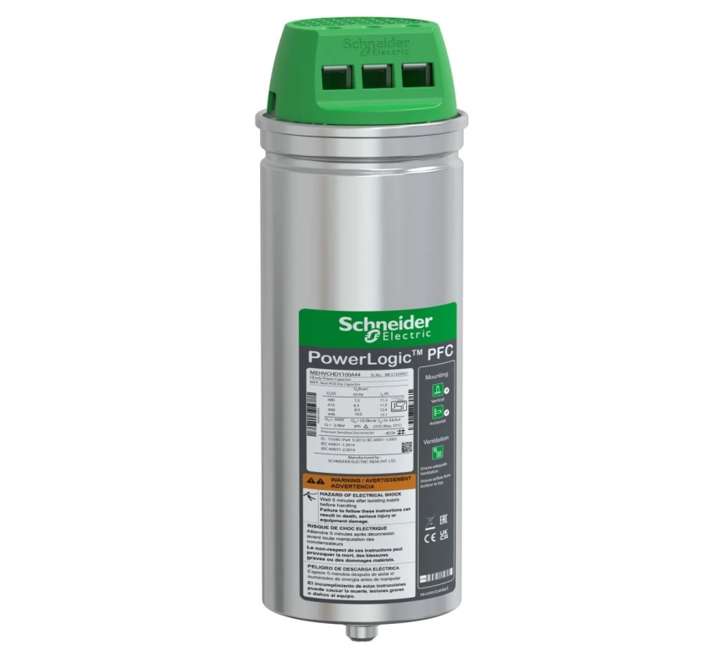

**PART NO-MEHVCHDY100A44**

**DESCRIPTION -10KVAR HD -440V**

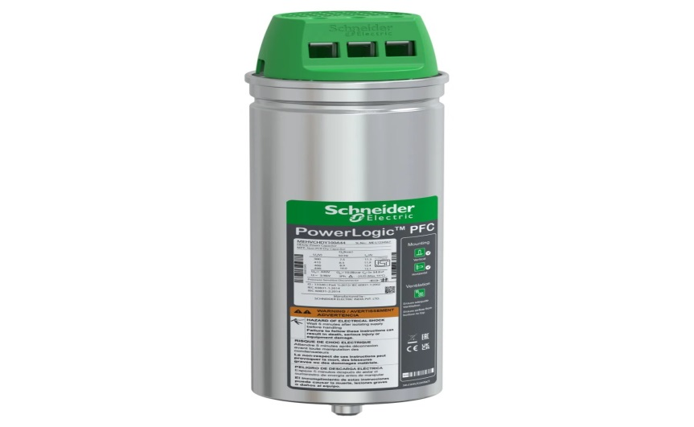

**PART NO-MEHVCHDY150A44**

**DESCRIPTION -15KVAR HD -440V**

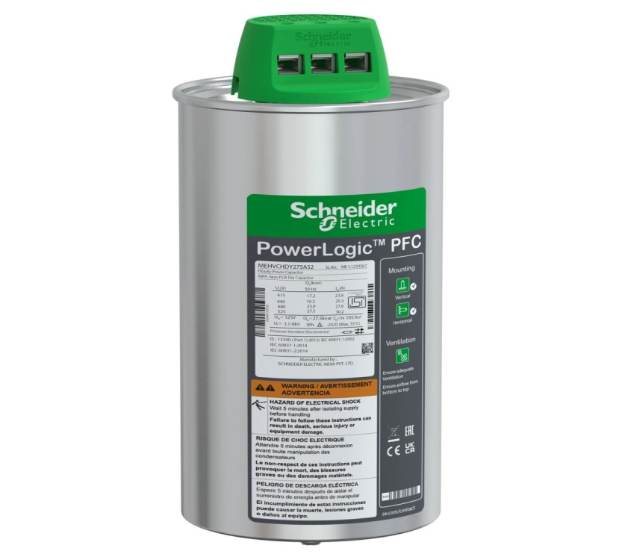

**PART NO-MEHVCHDY200A44**

**DESCRIPTION -20KVAR HD 440V**

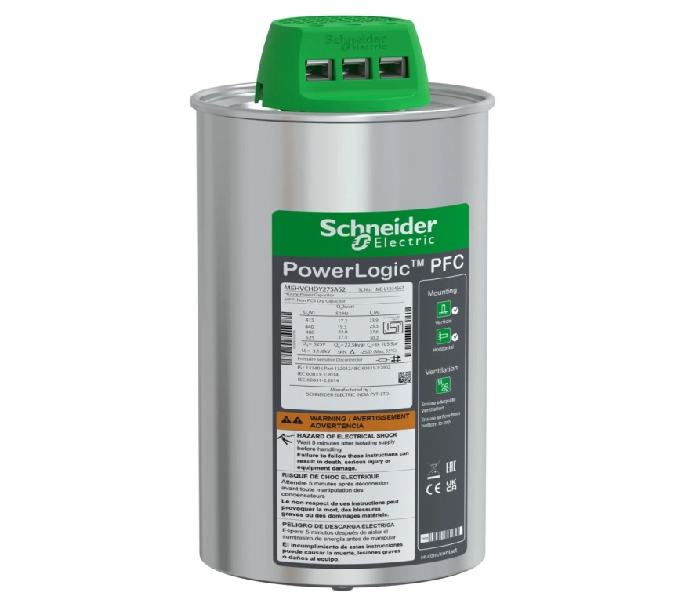

**PART NO-MEHVCHDY250A44**

**DESCRIPTION -(25KVAR HD 440V)**

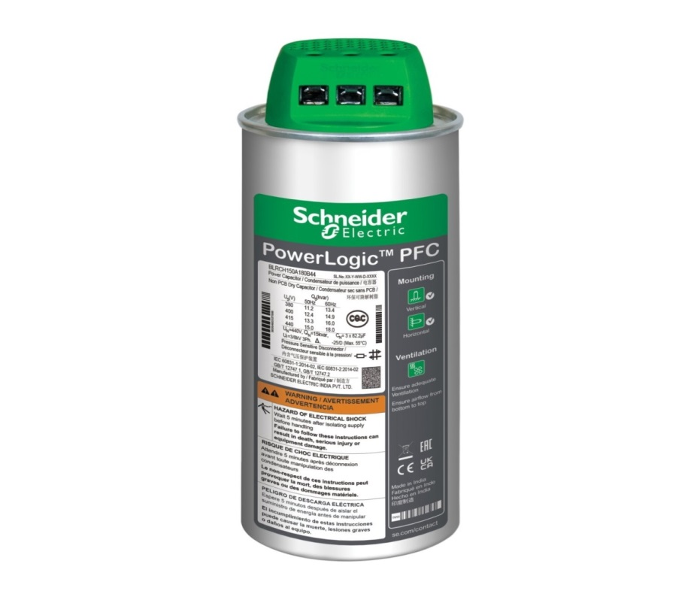

**PART NO-MEHVCHDY500A44**

**DESCRIPTION -50KVAR HD 440V**

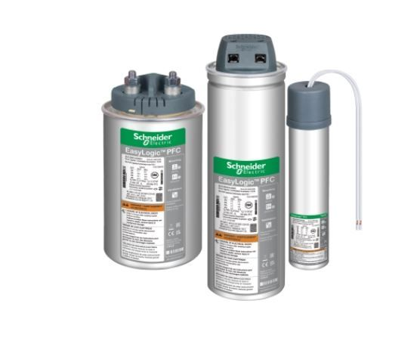

**PART NO-MEHVCGSF050A44**

**DESCRIPTION -5 KVAR GAS CAN 440V**

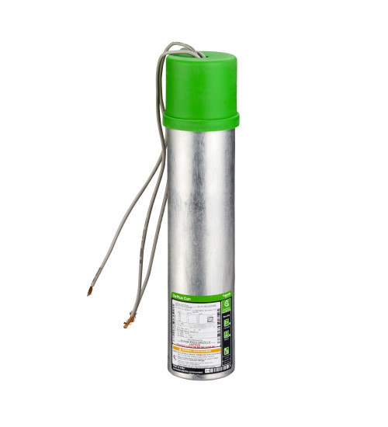

**PART NO-MEHVCGSF056A48**

**DESCRIPTION -5.6 KVAR GAS HD CAN 480V**

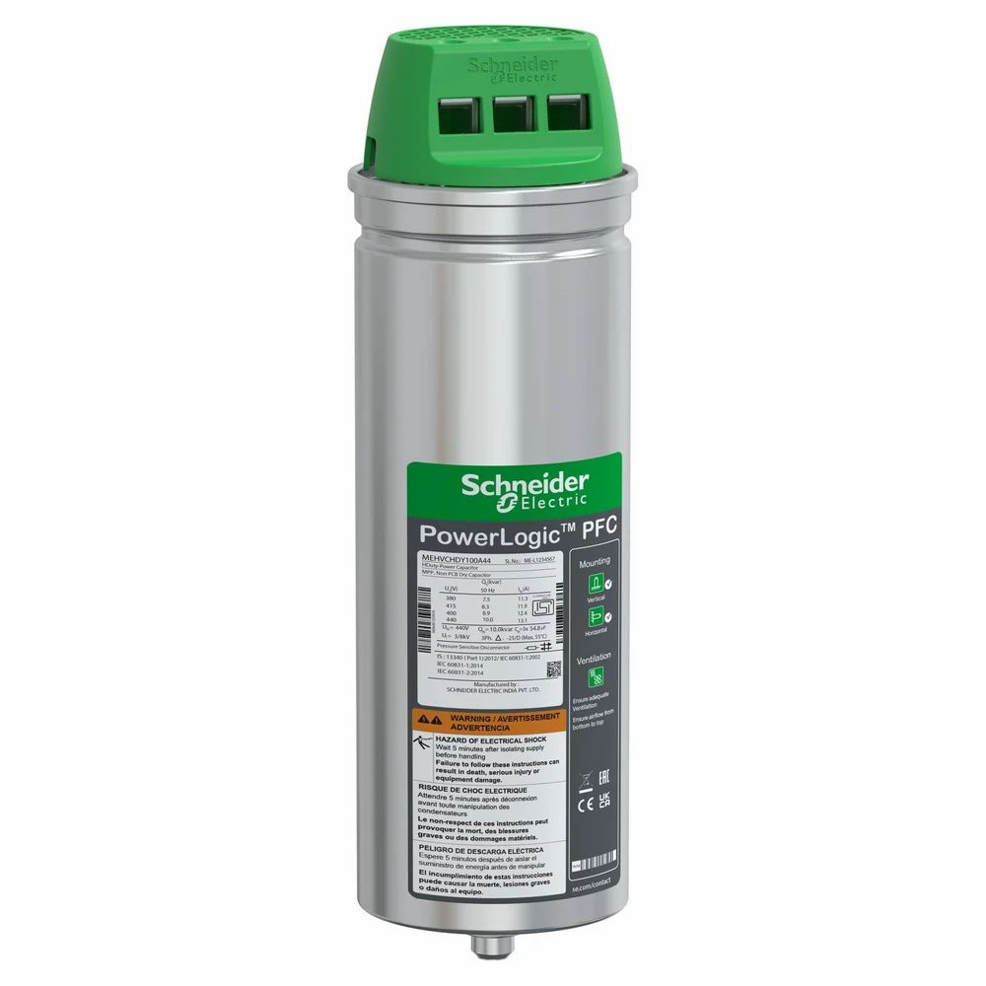

**PART NO-MEHVCGSF100A44**

**DESCRIPTION -10 KVAR GAS CAN HD 440V**

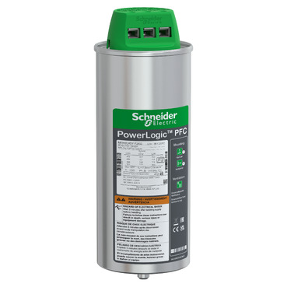

**PART NO-MEHVCGSF113A48**

**DESCRIPTION -11.3 KVAR GAS HD CAN 480V**

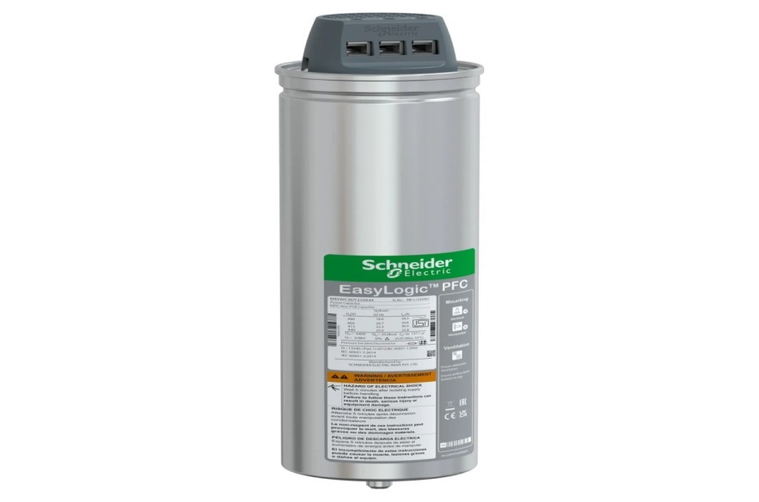

**PART NO-MEHVCGSF125A44**

**DESCRIPTION -12.5 KVAR GAS CAN HD 440V**

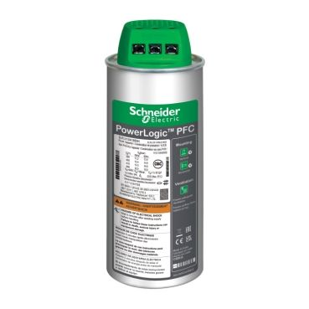

**PART NO-MEHVCGSF150A44**

**DESCRIPTION -15 KVAR GAS CAN HD 440V**



**PART NO-MEHVCGSF170A48**

**DESCRIPTION -17 KVAR GAS HD CAN 480V**

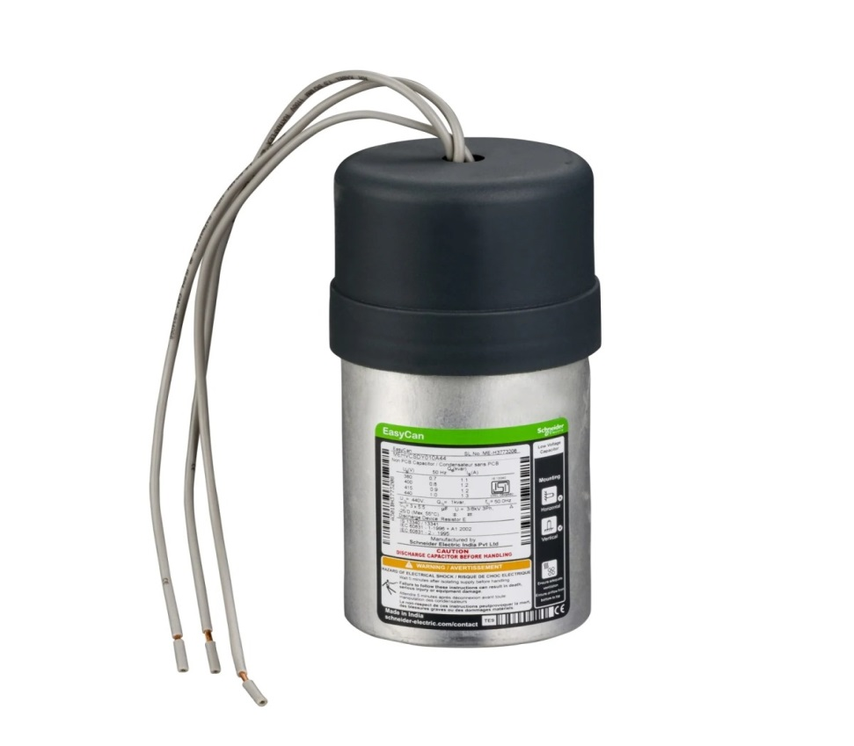

**PART NO-MEHVCSDY010A44**

**DESCRIPTION -CAPACITOR:1KVAR-CAN)**

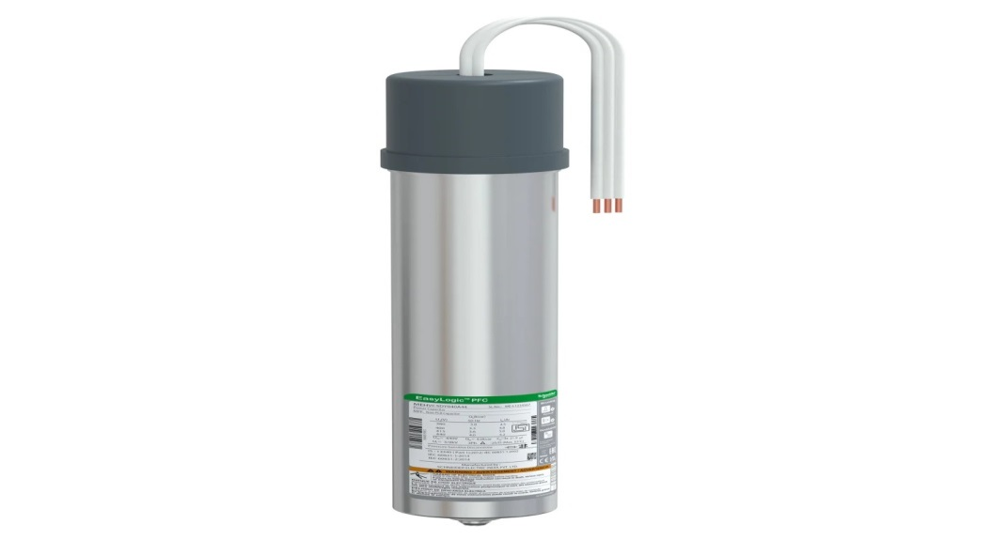

**PART NO-MEHVCSDY040A44**

**DESCRIPTION -CAPACITOR:4 KVAR-CAN)**

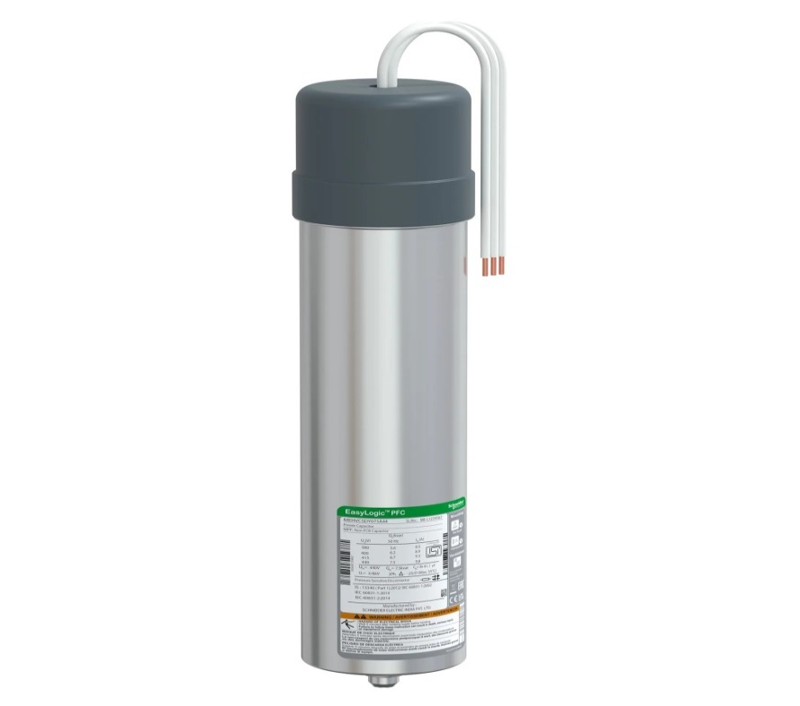

**PART NO-MEHVCSDY050A44**

**DESCRIPTION -CAPACITOR:5 KVAR-CAN**

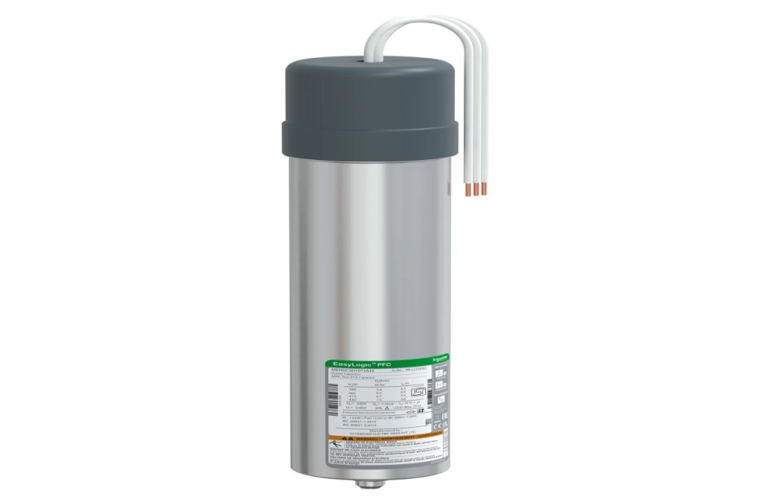

**PART NO-MEHVCSDY075A44**

**DESCRIPTION -CAPACITOR:7.5KVAR-CAN)**

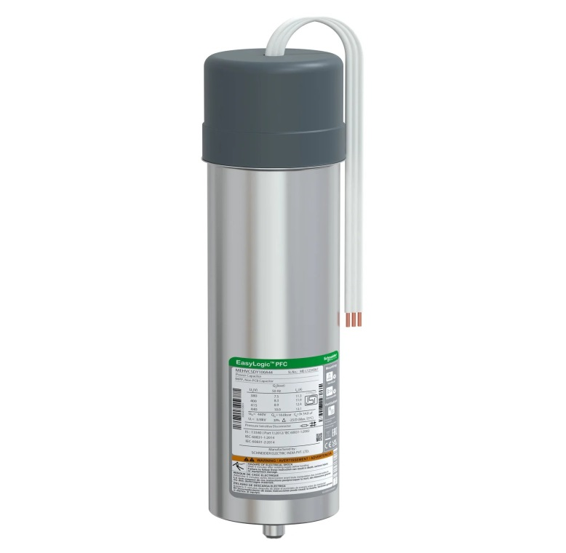

**PART NO-MEHVCSDY100A44**

**DESCRIPTION-CAPACITOR:10 KVAR-CAN**

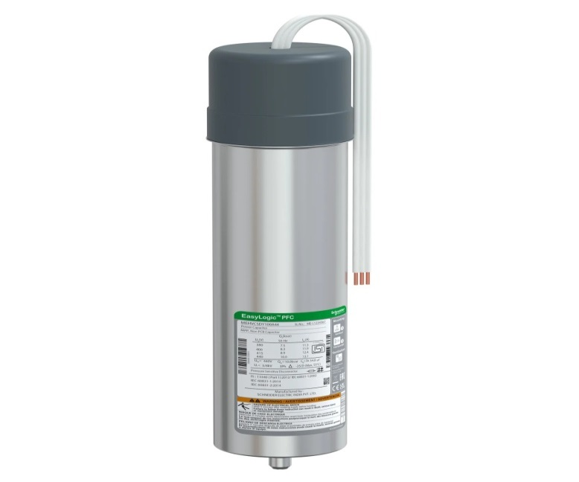

**PART NO-MEHVCSDY125A44**

**DESCRIPTION-CAPACITOR:12.5 KVAR-CAN**

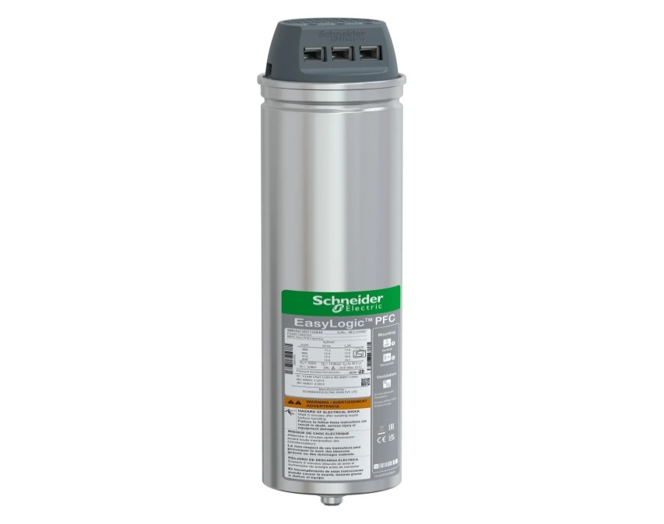

**PART NO-MEHVCSDY150A44**

**DESCRIPTION-CAPACITOR:15 KVAR-CAN**

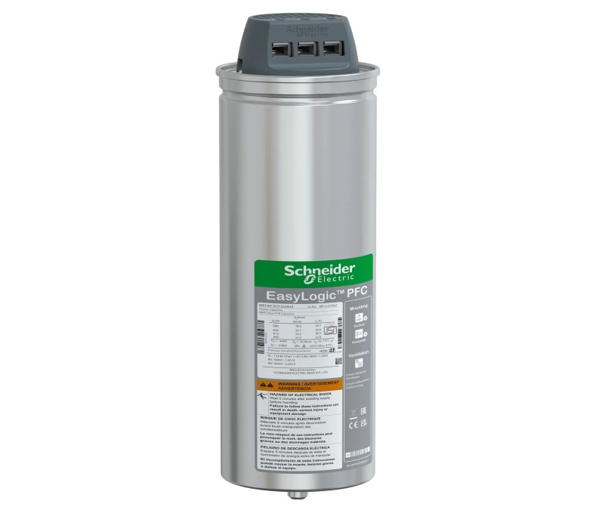

**PART NO-MEHVCSDY200A44**

**DESCRIPTION-CAPACITOR:20 KVAR-CAN**

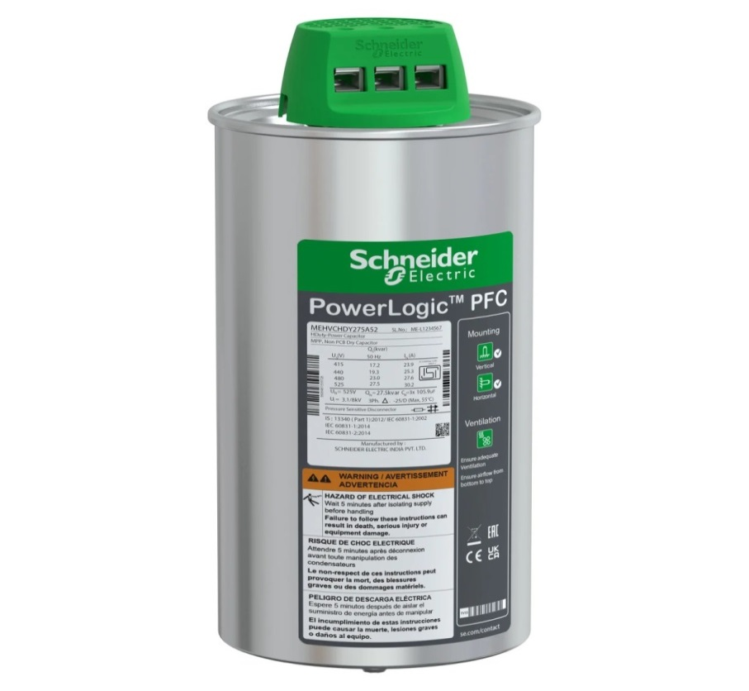

**PART NO-MEHVCSDY250A44**

**DESCRIPTION-(CAPACITOR:25 KVAR-CAN)**

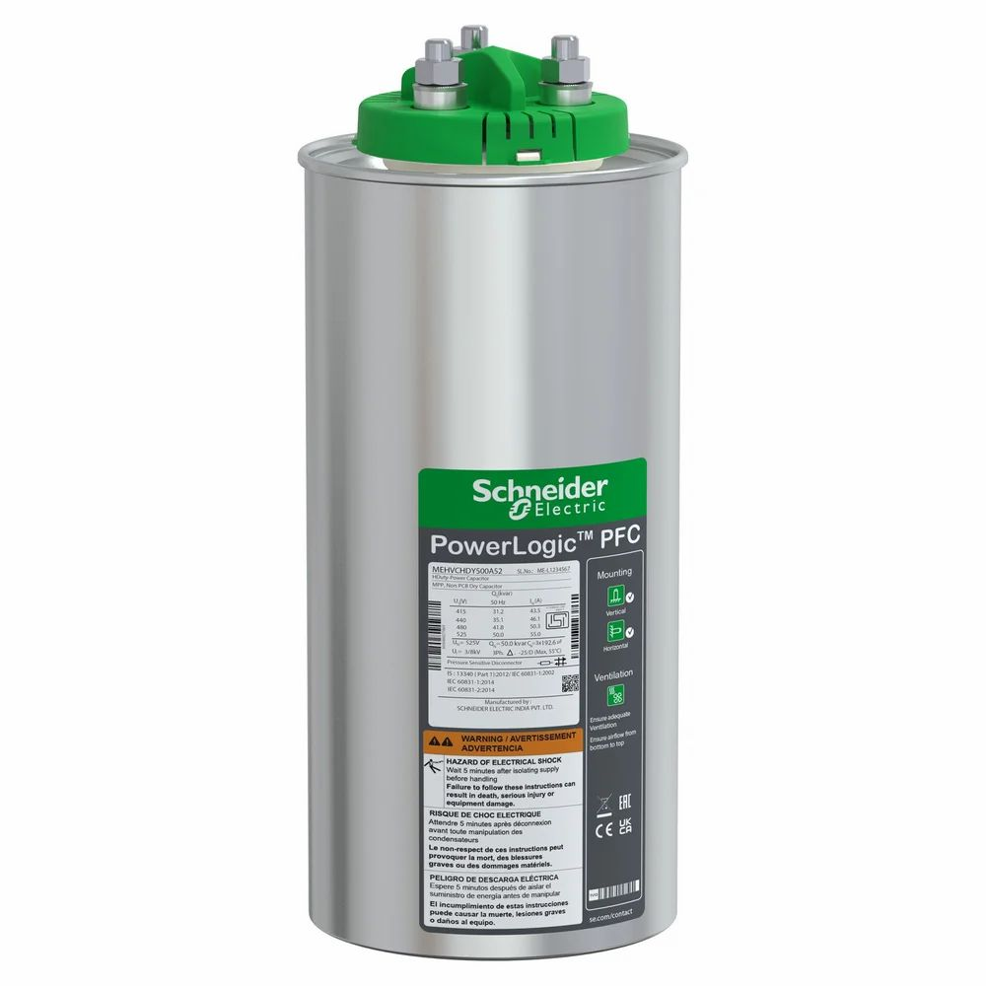

**PART NO-MEHVCGSF500A44**

**DESCRIPTION -50 KVAR GAS CAN 440V**

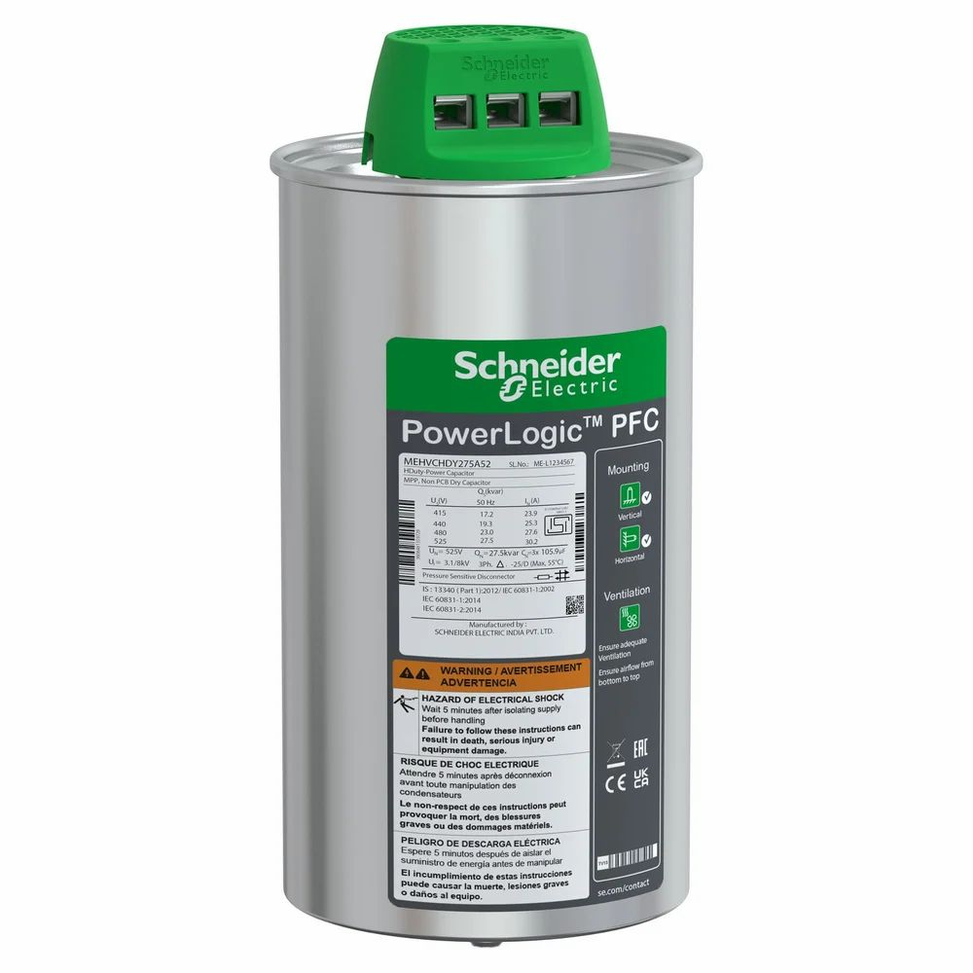

**PART NO-MEHVCGSF250A44**

**DESCRIPTION-25 KVAR GAS CAN 440V**



**PART NO-MEHVCGSF100A44**

**DESCRIPTION-10 KVAR GAS CAN HD 440V**

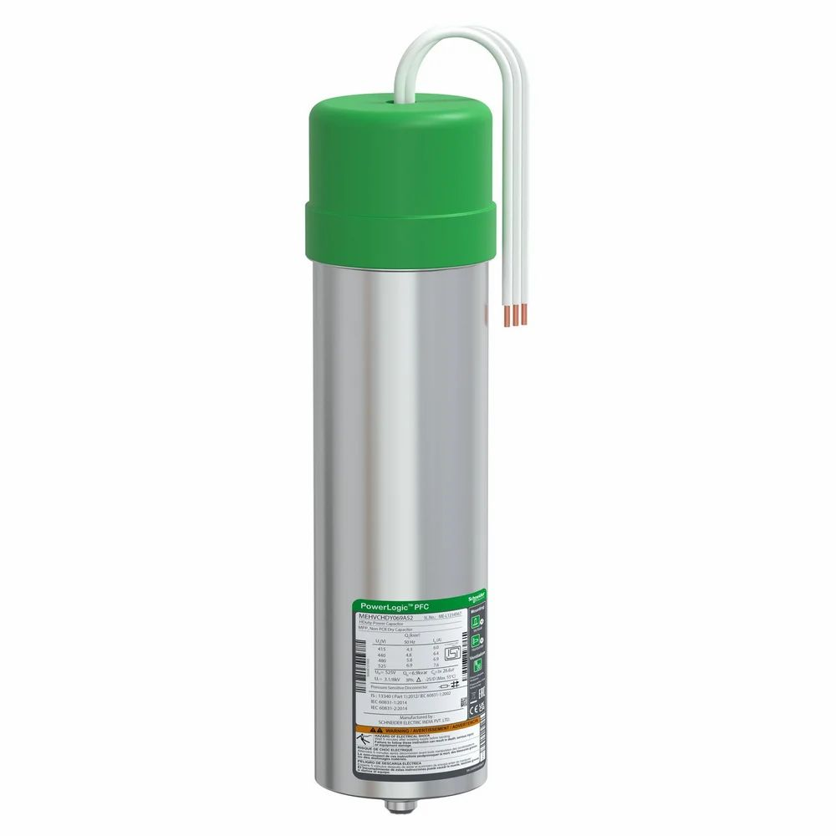

**PART NO-MEHVCGSF050A44**

**DESCRIPTION-5 KVAR GAS CAN 440V**



PART NO-MEHVCGSF125A44

DESCRIPTION-12.5 KVAR GAS CAN HD 440V



**PART NO-MEHVCGSF150A44**

**DESCRIPTION-15 KVAR GAS CAN HD 440V**



**PART NO-MEHVCGSF200A44**

**DESCRIPTION-20 KVAR GAS CAN 440V**

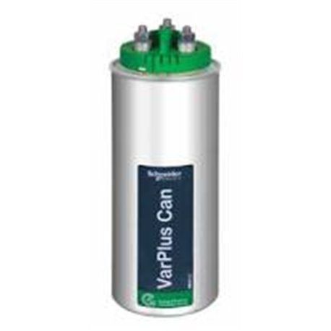

**PART NO-MEHVCHDY056A48**

**DESRIPTION-5.6KVAR HD CAPACITOR 480V**

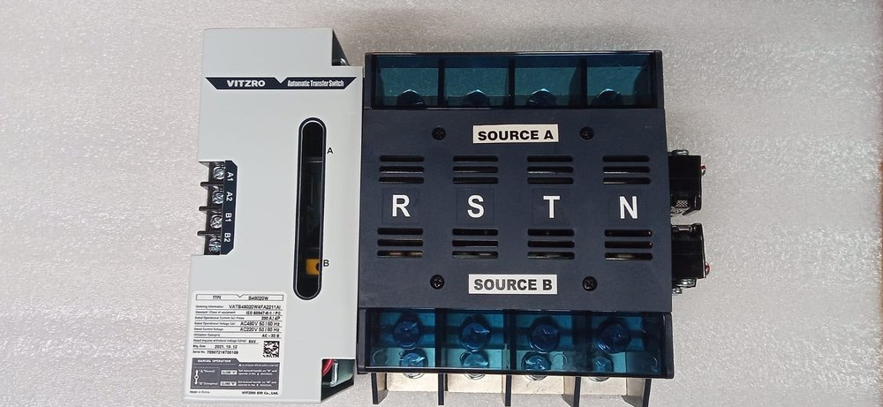

**100A 4P ATS**

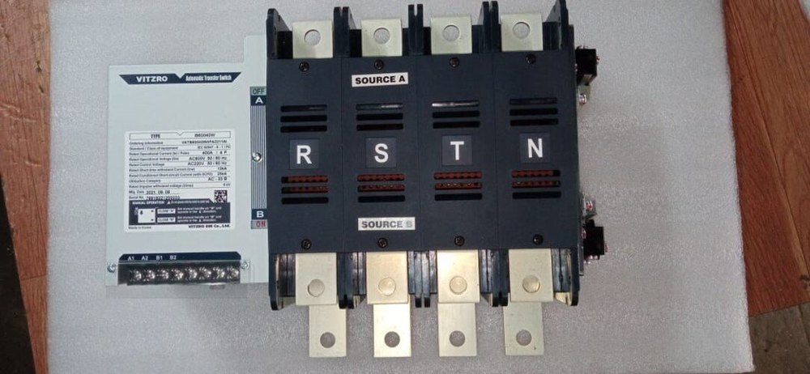

**400A 4P ATS**

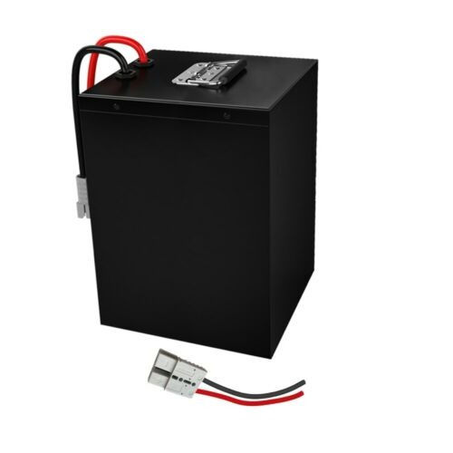

**48V LITHIUM BATTERY**

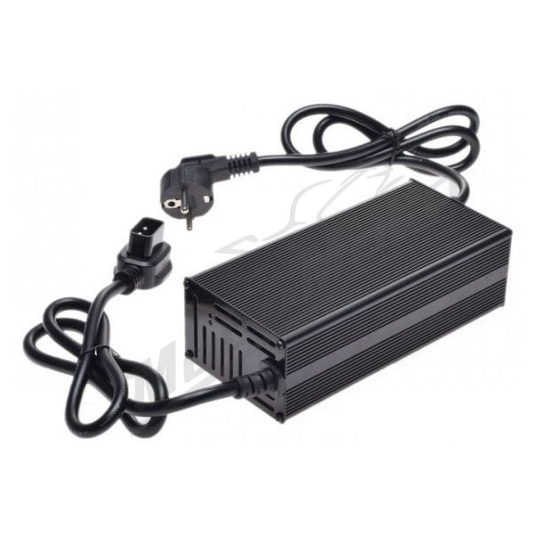

**48V 5A CHARGER**



**60V LITHIUM BATTERY**



**60V 5A CHARGER**



**ETHERNET MODULE (PM8ECC)**

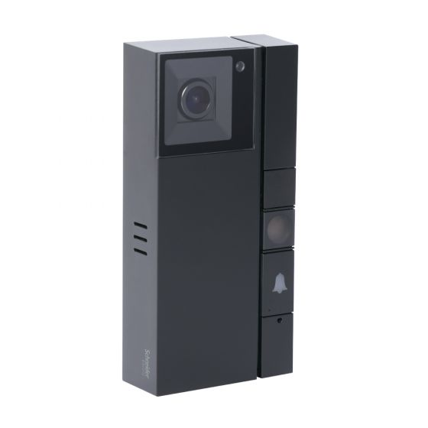

**IH100WFVDP (SMART DOORBELL)**

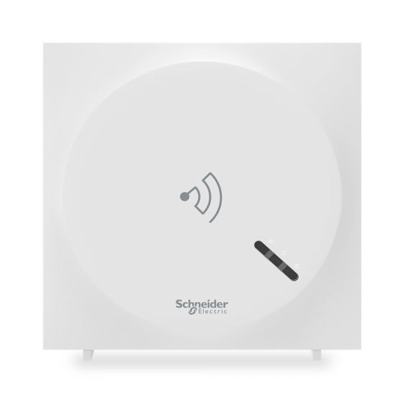

**IH101ZWIFI (AUTOMATION GATEWAY)**

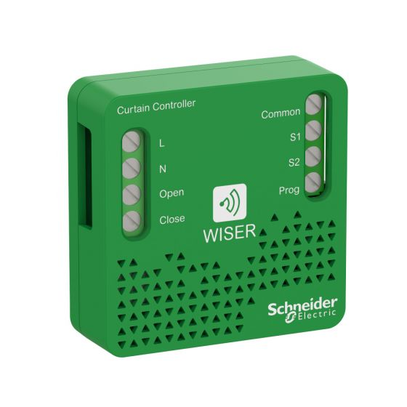**IH11000200**

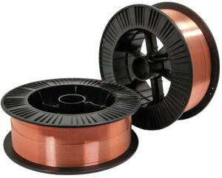 **NOVAK MIG WELDING WIRE**

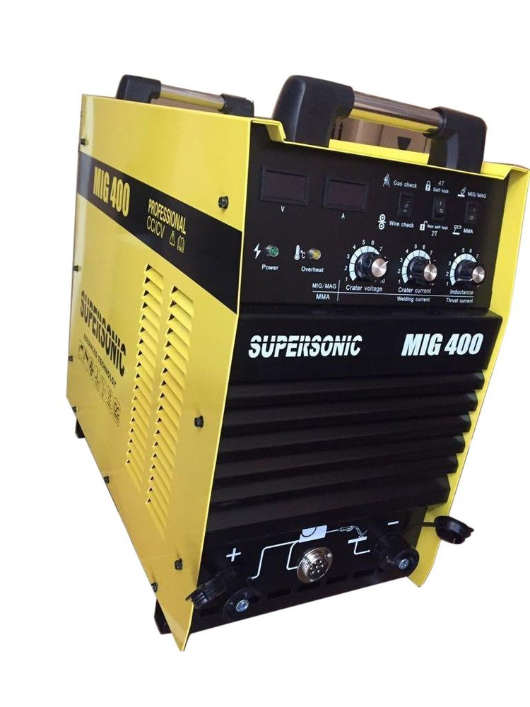

**SUPER SONIC SEMI AUTOMATED WELDING MACHINE**